Lifesaving rules
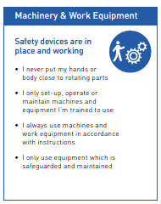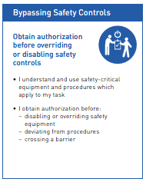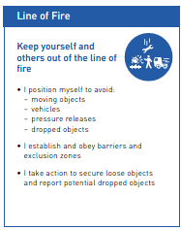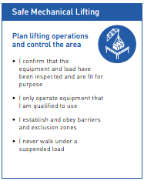

Significant hazards
 | - Entanglement with rotating parts  - Ejection of workpieces or tooling.  - Contact with cutting tools and rotating components.  - Flying swarf and metal chips.  - Manual handling of heavy components.

Additional safety precautions
 | - When machining abnormal workpieces, a Point of Work (Dynamic) risk assessment MUST be carried out to assess the risks. |  | - Ensure all guarding is in place and any interlocks are working.
 | - Rings and jewelry must not be worn or be covered in work areas. |  | - Hearing protection should be worn if the indicators are red. Ensure others in the area are complying.
 | - Long and loose hair / Loose articles must be contained or secured. |  | - Where fitted, ensure inbuilt LEV is switched on or use mobile LEV if a lot of smoke or fume is being produced.

PPE requirements
 | - Safety glasses  - Single piece coveralls (Short sleeves)  - Safety footwear
 | - Gloves must not be worn near rotating equipment  - Cut-resistant gloves must be worn when handling swarf, tooling, and when loading or unloading components onto or from the lathe  - Chemical-resistant gloves must be worn when changing coolant and when handling chemicals or oils

WARNING: Do not operate this machine unless you have received formal training in its safe use, have been assessed and proven competent, and are authorised to operate it through successful completion of a competency assessment.
Step | Pre-operational safety checks
1 | Ensure the work area, table and floor are clean, dry and free from unnecessary items.
2 | Check emergency stop and normal controls appear serviceable; do not bypass any safety device.
3 | DC injection brake functional
4 | Emergency stop functional
5 | Spindle guard fitted, in good condition, and its interlock functional.
6 | No visible machine damage or oil leaks

Step | Housekeeping
1 | Switch off the machine and reset all guards to a fully closed position.
2 | Leave the machine in a safe, clean, and tidy state.

Step | Operational safety
1 | Faulty equipment must NOT be used. Immediately report suspect machinery.
2 | Machine operator MUST NOT leave the machine unattended while operational and MUST always maintain vigilance.
3 | Set the correct speed and feed before starting. Make speed-range or drive changes only as permitted by the machine manufacturer and with the machine stopped where required.
4 | Avoid letting swarf build up on the tool or job. Stop the machine and remove it using a swarf hook or brush. Wear cut-resistant gloves.
5 | Stand in a stable position, keep hands clear, and start the spindle using the normal control.
6 | Apply feed smoothly. Do not force the tool. Monitor the cut, workholding, sound, vibration and chip formation
7 | Ensure all applicable guards are in place while operating the machine.
8 | Use a brush, chip hook or suitable tool to remove swarf only when it is safe to do so. Never clear swarf with bare hands
9 | Stop the spindle before measuring, checking the hole, repositioning/clamping the work, changing tools, adjusting the workpiece or leaving the machine unattended

Step | Loading, unloading & set-up
1 | With the spindle stopped, position the radial arm and drill head to align the tool with the work. Clamp the arm/head/column as required by the machine design
2 | Mark and locate the drilling position using the approved job method
3 | Set the correct speed and feed before starting. Make speed-range or drive changes only as permitted by the machine manufacturer and with the machine stopped where required
4 | Apply feed smoothly. Do not force the tool. Monitor the cut, workholding, sound, vibration and chip formation
5 | Remove the chuck key and all setting tools before starting the spindle
6 | Position the workpiece on the table/base and secure it using a vice, clamps, fixtures or suitable bolting. Never hold the workpiece by hand.
7 | Confirm the intended spindle speed and feed are suitable for the material, tool diameter and operation
8 | Check machine head, radial arm and column are correctly positioned and clamped before cutting
9 | Arrange coolant, if required, and verify hoses will not contact rotating components
10 | Do not use the machine if abnormal noise, damage, leakage, loose components or unsafe conditions are found. Tag/report the defect according to site procedure
11 | Repeat until the workpiece is running within the required tolerance.
12 | Remove all tools from the bed and slides of the machine.
13 | Remove crane lifting accessories.

